**Database Management System (CS-204)**

**First Progress Report**

                                                           April 17, 2020

**Course Instructor: Dr. Antriksh Goswami**

**Student ID(s) and Name(s):  Sudhanshu Pandey (201851131), Gaurav Singh (201851044)**

_____________________________________________________________________________________

**Requirements**: Java, SQL, Visual Studio Code, NetBeans(optional), GitHub

**Timeline of the Project:**

**First Week:**

                    In first week, we will focus on design of our frontend and we will code our frontend with the help of java and NetBeans. We will also try to make our database in MySQL in this week

**Second Week**:

                        In second week, we will try to access the data from our database and will try to place that that data in exact position at our frontend design and will try to complete our login option for student, faculty and admin of our project.

**Third Week**:

                      In this week we will also begin the work on our student, faculty and admin module. After this week student will be able to see his personal details, faculty can also see his personal details admin can add new records. Remaining work of these module will be finished in next week.

**Fourth week**:

In this week we will finish the work from previous week i.e. completion of all three modules and all its feature. After completion of this week student will be able to see his personal details, result, attendance status, courses enrolled and faculty teaching that courses and some other features similarly faculty will be able to assign grade and attendance to students and can see the students who are enrolled in his/her course and can also see the students who to whom he is an advisor. Admin will be able to edit the all types of required records and can add or delete the records also.

**Fifth Week**:

                      In this week, we just sum up all the works of team members and connect them.

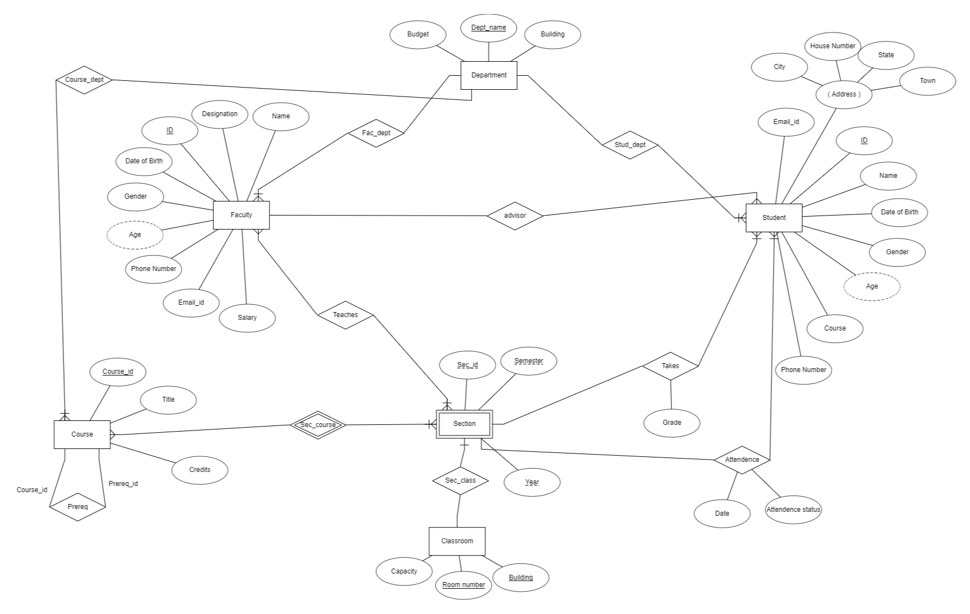**E-R Diagram**

In our Institute Management System database there are total 5 strong entity (Department, Student, Classroom, Course, Faculty) and 1 weak entity (Section).

The Entities with its attributes are as follows

1. **Department (**Dept_name (Unique), Building, Budget**)**
2. **Student (**ID (Unique), Email, Name, Date of Birth, Gender, Phone Number, Age (Derived), Address (Composite), Course**)**
3. **Section (**Sec_id­­­­­­­­­, Semester, Year (all are unique)**).** It is a weak entity which depends on entity Course i.e. it cannot exist without Entity course
4. **Classroom (**Room Number (Unique), Building (Unique), Capacity**)**
5. **Course (**Course_id (Unique), Title, Credits**)**
6. **Faculty (**ID (Unique), Name, Date of Birth, Gender, Designation, Salary, Email_id, Phone Number, Age (Derived)**)**

The Relationships are as follows

1. **Department-Student (**Stud_dept**)-**It is one to many relationships i.e. A Department can have many students and a student will have only one department also there is total participation of student i.e. A student must belong to any department.
2. **Department-Faculty (**Fac_dept**)-** It is one to many relationships i.e. A Department can have many Faculties and a Faculty will have only one department also there is total participation of Faculty i.e. A student must belong to any department.
3. **Student-Faculty (**Advisor**)-** It is many to one relationship. A faculty can advise many students but student can have only one advisor.
4. **Course-Section (**Sec_course**)-** It is many to many relationships. A course can be taught in many sections and a section can have may courses.it is weak relationship section cannot exist without course.
5. **Section-Classroom (**Sec_class**)-** it is one to one relationship and section must have a classroom.
6. **Section-Student (**takes**)-**this relationship has an attribute (grade). It is one to many relationships.
7. **Section-Student (**Attendance**)-**this relationship has two attributes (Date, Attendance Status). It is one to many relationships.
8. **Faculty-Section (**teaches**)-** It is many to many relationships. A section can have may Faculty and a faculty can teach in many sections.
9. **Course-Course (**prereq**)-** It is one to one relationship. A course will have one previous required course.
10. **Course-Department (**Course_dept**)-** it is many to one relationship. Many courses can be associated with a single department and a course must have a department.

**End Users expectation**:

Any user if he is a student will be able to see his grade in respective courses, his attendance status, his personal details, about his faculty advisor, about his faculty, courses he/she is enrolled. If the user is a faculty the he/she can assign grade and attendance to students and can see the students who are enrolled in his/her course and can also see the students who to whom he is an advisor. Admin will be able to edit the all types of required records and can add or delete the records also